**STEP 1 – CREATE THE FORM**

Use the project we build last time – we are going to add our templates

1. In animals app create folder called (‘templates’). This is a Django convention – we must create a folder for templates in app called templates. We can overwrite this name but the default is that. After that in animals/templates create a html file called ‘create’.
2. Form data is stored in an application's forms.py file, inside the application directory. Create and open the file **store/animals/forms.py**. To create a Form, we import the forms library, derive from the Form class, and declare the form's fields.
3. We are going to create form by our Animal model so we inherit forms.ModelForm and describe the fields which are in out model

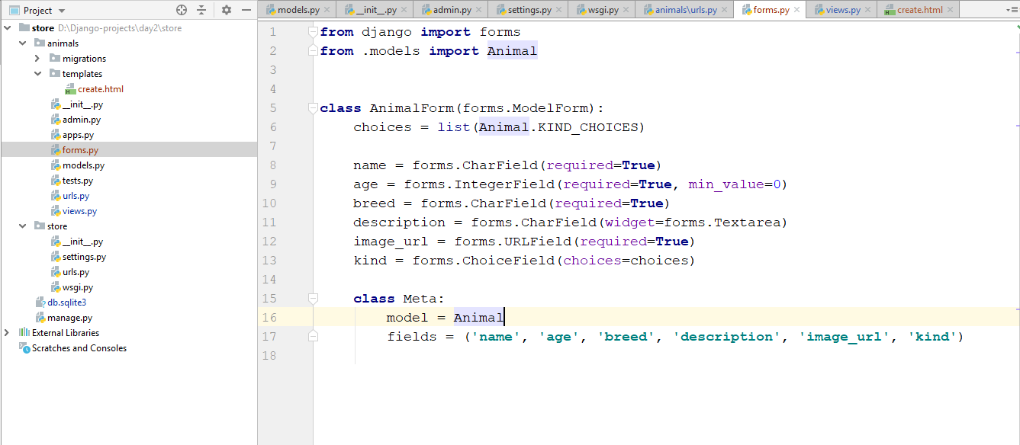

We need this Meta class inside our classForm in order to describe the model and the fields we want.

1. Let’s replace in our urls.py in animals app the create path function with ‘create_animal_form’
2. Go to Views and create this function, which takes request as param.
3. Write the code

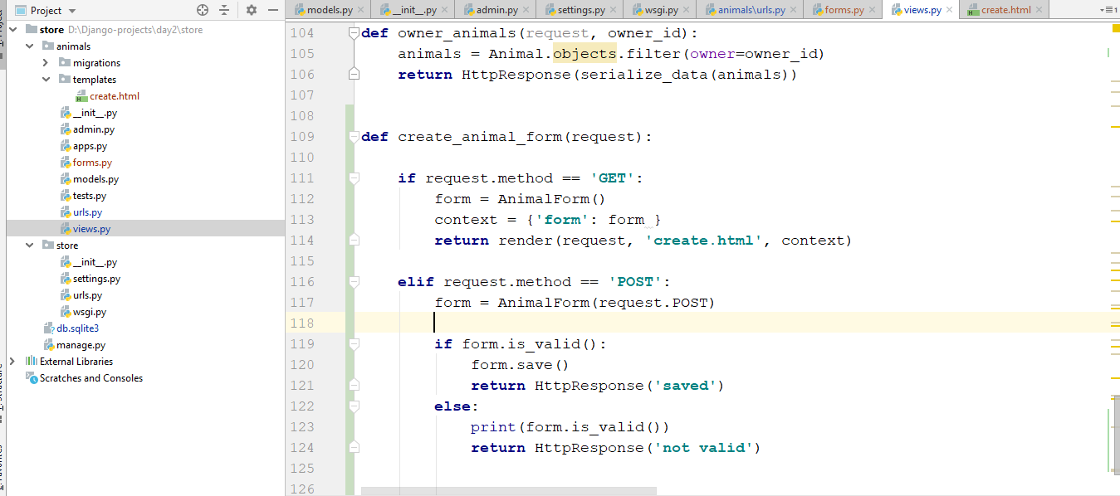

1. Create content in html file  
   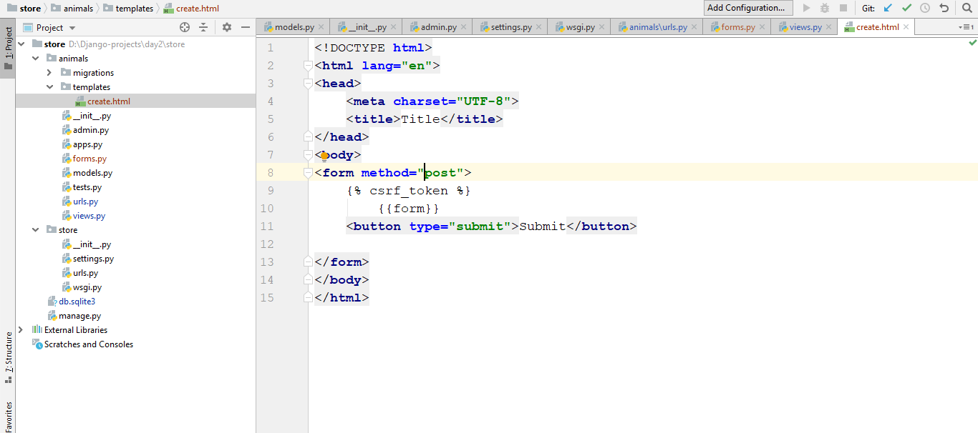
2. Go to the url animals/create and you should see the following:

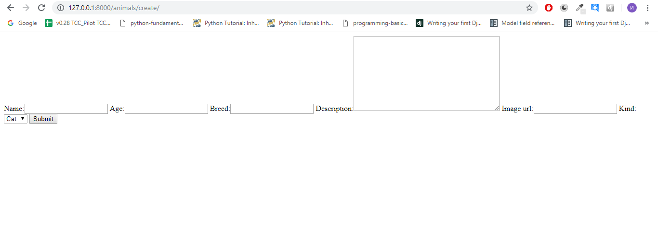

1. Go to admin panel and check if the new data is in DB when you submit the form

**STEP 2 – VALIDATE THE FORM**

Note that Django provide validators

1. Validate every field to be required, after that

use RegexValidator in name field to be sure that the name of the animal always will start with a capital letter (Latin) after that lowercase letters (Latin letters)

1. Add another validators and explore how they work

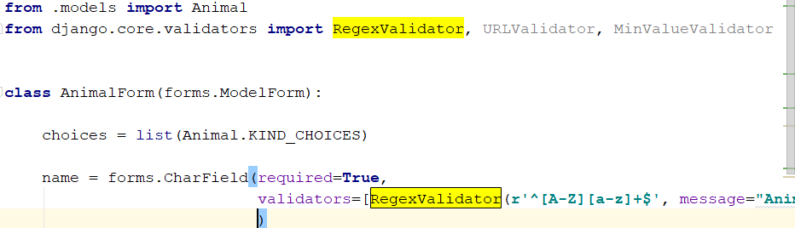

1. You should discover on your own how to display this errors

**STEP 3 – MAKE THE FORM LOOKS PRETTIER**

Django provides some other helpful stuff. We can add widgets and there we can add our custom or bootstrap classes to make our form looks nice and pretty.

First add from bootstrap link in the head of our animals/templates/create

<https://getbootstrap.com/docs/4.3/getting-started/introduction/>

You will need this

<link rel="stylesheet" href="https://stackpath.bootstrapcdn.com/bootstrap/4.3.1/css/bootstrap.min.css" integrity="sha384-ggOyR0iXCbMQv3Xipma34MD+dH/1fQ784/j6cY/iJTQUOhcWr7x9JvoRxT2MZw1T" crossorigin="anonymous">

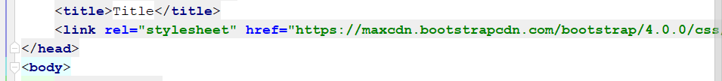

Bootstrap is a css framework and provides us the opportunity to use grid system very easy. Change your body to look like this –

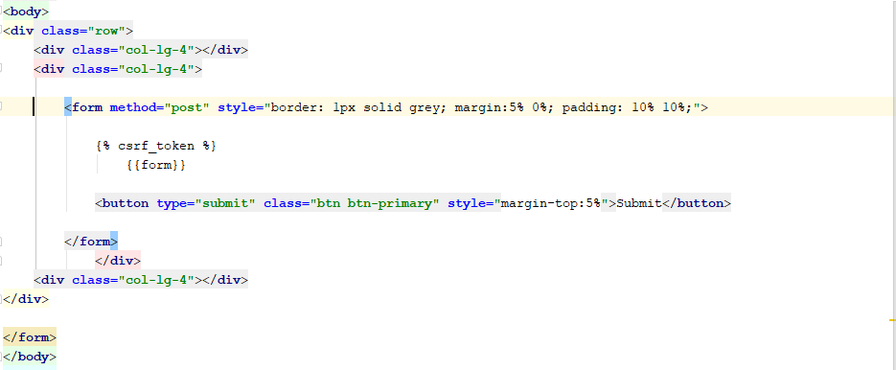

After that go to forms.py and add widgets to all of our fields with bootstrap class ‘form -control’

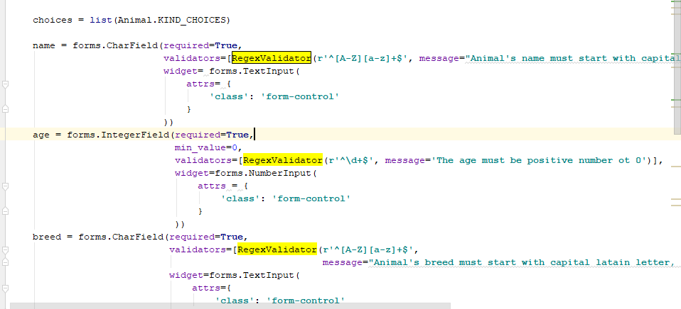

When you add to all fields will we have the final result:

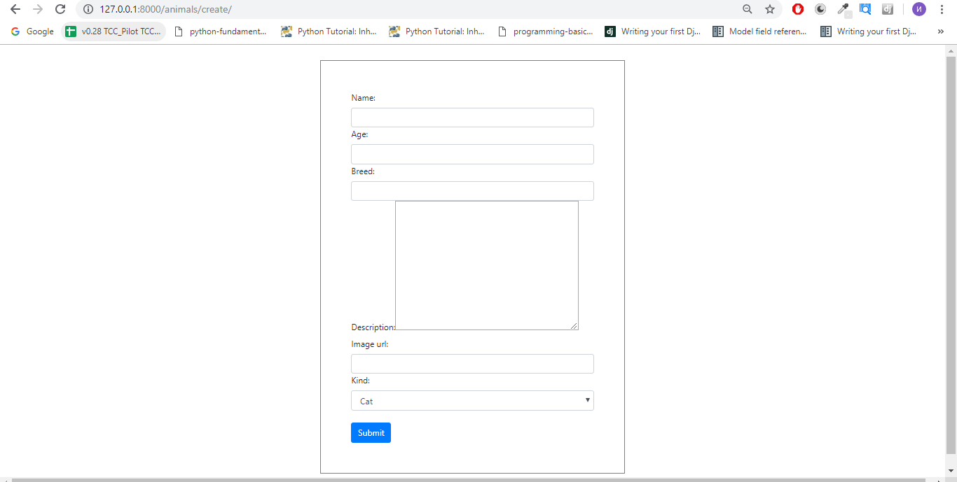

And we are done – we have nice looking modern feel on our form.

**OPTIONAL – LIST ALL EXISTRING ANIMALS**

As final result we can expect this:

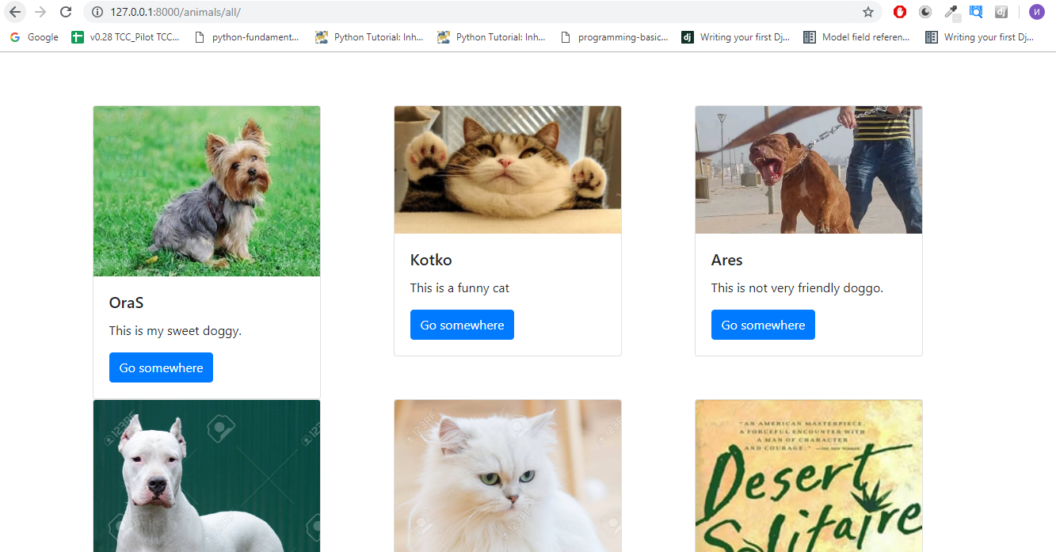

HINTS:

* Create another html file in templates
* Use bootstrap classes and grid system
* In views make function return this template
* Use bootstrap ready component – card
* Use template syntax to go through every animal and for every animal create col in which you have bootstrap card and render the current animal data

MAKE IT BUT DJANGO’S WAY:

In order to be even more easy for us and to not write any code we could do that:

* Make sure that template name ends with ‘list’
* Import from Django.views.generic import ListView
* Create in your views.py a **class** which inherits ListView
* Set model to be Animal

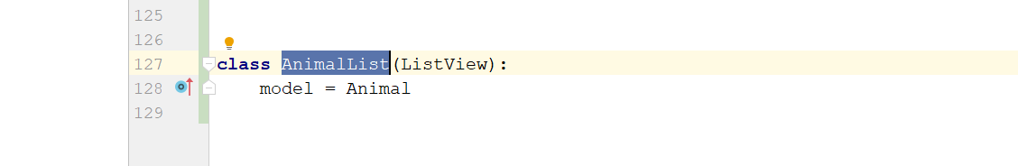

Enjoy the power of two line code with the awesome Django framework ☺